FUNCTIONAL COATINGS FN NANO®

INSTRUCTIONS FOR APPLICATION

OWNER OF PATENT AND MANUFACTURER:

Advanced Materials – JTJ s.r.o.
273 01 Kamenné Žehrovice 23
Czech Republic
www.advancedmaterials1.com

DISTRIBUTOR:

FN-NANO s.r.o.
273 01 Kamenné Žehrovice 23
Czech Republic
www.fn-nano.com, www.fn-nano.cz

CZECH INVENTION, PROTECTED BY PATENT AND FN® TRADEMARK

VERIFIED BY MORE THAN TEN YEARS OF PRACTICAL EXPERIENCE

CONTENTS:

HOW TO PROCEED WHEN APPLYING FN NANO® COATINGS — IMPORTANT RECOMMENDATIONS... 3-4

TABLE OF USE FN NANO® COATINGS — SURFACES... 5

PRINCIPLES THE SAME FOR ALL KINDS OF APPLICATIONS IN THE INTERIOR... 6

WORKFLOW OF APPLICATION OF FN NANO® COATINGS IN THE INTERIOR. VIDEO INSTRUCTIONS:
DESCRIPTION WORKING IN INTERIOR — plasterboard — older painting... 7-8
VIDEO INSTRUCTIONS WHEN APPLYING A PAINT ROLLER... 8
DESCRIPTION WORKING IN INTERIOR — plasterboard — new painting... 9-10
HOW AND WHEN TO LIGHT THE SURFACE FN NANO® UVA... 10-12

PRINCIPLES THE SAME FOR ALL KINDS OF APPLICATIONS IN THE INTERIOR... 13

WORKFLOW OF APPLICATION OF FN NANO® COATINGS IN THE INTERIOR. VIDEO DEMOS... 13
DESCRIPTION WORKING IN EXTERIOR — facade — renovation incl. video instructions... 14-15
DESCRIPTION WORKING IN EXTERIOR — new facade... 16-17
IMPORTANT WARNINGS, CONCLUSION... 17

HOW TO PROCEED WHEN APPLYING FN NANO® COATINGS — IMPORTANT RECOMMENDATIONS

- Apply FN NANO® functional coatings only to a suitable and cohesive substrate. Silicate and acrylic paints are also suitable substrate. If you are unsure of the suitability of the substrate, it must be tested by performing a FN NANO® test coating (near a window) on a small piece, leaving it to dry and checking the next day for flaking, cracking, peeling or yellowing. In this case, the old paint must be removed and repainted with a suitable paint.

- An inappropriate substrate is surfaces with a strong hydrophobic (water-repellent) effect. FN NANO® is an aqueous suspension. On such a surface, it “packs” into balls, and a continuous coating layer can not be made with it. The substrate created with the help of wedged colors is not suitable. Such an old coating must be scraped and washed away.

- Care must be taken to ensure that when applying the functional coating FN NANO® does not loosen the substrate. In this case, organic substances can be washed out from the substrate into the coating created by the functional coating. This can manifest itself with rusty spots. However, these spots usually disappear after some time, as a result of the photocatalytic effect. In the interior, it is recommended to always use deep penetration solution in advance and prime the surfaces with quality silicate paint.

- In case FN NANO® functional coatings are applied to walls that are heavily stained by smoke pollution (such as restaurants, bars, chicken shops, etc.), a primer is required before applying FN NANO®, load through depth penetration. Otherwise, dirt deposited inside the plaster and wall can rise into the surface layer. It might therefore turn yellow, and become stained..

- To create, for example, 10 m2 interior of photoactive surface, it is necessary to apply 1 liter to this area evenly — in three layers (undiluted and perfectly mixed!!!) FN NANO® functional coating. This quantity is optimal to ensure sufficient strength of the photoactive layer, which will be created by applying the paint. The uniformity of applying the material and the thickness of the formed layer are a necessary condition for ensuring its proper functionality. In the event of non-compliance with this application principle and the formation of a too thin, weak layer (for example, through unequal treatment or dilution of the paint with water), the photocatalytic effect may also act on the substrate, this is manifested by his yellowing and odor. Also, the execution of a too thick layer is not desirable especially because of the risk of cracks and flaking.

- The individual layers must be applied so that the following layer is applied to well applied preceding layer. Apply the third layer only after the previous two layers have completely dried.

- If the goal is to create a surface that allows easy removal of graffiti, 6 or more layers of FN® 1 functional coating with FN® 2 NANO® should be applied. Removing graffiti is simple. The optimal procedure is to spray the area treated with FN NANO® first generously with water and then clean the surface with the graffiti with a stiff brush and then sprayed finally with pressurized water. 6 and more layers of FN2 NANO® functional coating must be reapplied to the surface where the removal of graffiti was carried out.

- FN NANO® functional coating can be applied using a brush, roller or spray.

- The spraying method ensures uniform application of the material, rapid work progress and lower consumption on the solid surface. Spray with a device that creates the finest possible droplets. Professional or semi-professional spray guns of the HVLP type with nozzles designed for paint work have proven suitable for interior design. For applications of large areas in the exterior, it is also possible to use airless high-pressure spray devices with a coating mixer. For the application of FN NANO® coatings, we do not recommend mechanical nebulizers and sprinklers because they do not create even droplets.

- Spray as evenly as possible. In this way, apply the formed aerosol “mist” evenly and in a thin layer on the target surface. Take care not to create wet shiny places when spraying on the substrate. They are a symptom of the formation of too large a layer. The paint on them can trickle down, there may also be a dents of the substrate, or a cracking.

- Verified semi-professional instruments: Wagner W550, Gracco and others. Use of other types of equipment is possible.

- For roller application, low-profile paint rollers are mostly suitable in the interior. For applications on a rough surface (for example, facade) we recommend rollers with a higher hair or a combination of a roller and brush (if there are many rough surfaces). The application must be carried out with an unruffled roller at a brisk pace so that, especially for more soaring substrates, they do not sweep and excessive consumption of the material. The use of a brush is suitable in cases where it is not possible to use spraying or applying with a roller. Always follow this to create a continuous layer.

- Areas not treated with FN NANO® functional coating and objects in rooms where the paint is applied must be thoroughly covered with a protective sheets (dropcloth). Sections of protective sheets are recommended to overlay and fasten with a painter's “masking” tape.

- In order to ensure the functionality of the photoactive layer, it is necessary that the areas treated with the FN NANO® functional coating experience enough daylight or ensure sufficient artificial source of ultraviolet (UVA) light (best are lamps or bulbs in the range 350 — 375 nm, optimal wavelength for photoactivation is 365 nm). The minimum power of the source in relation to the enhanced area shall be governed for UV-A fluorescent lamps according to rule 1W of the electrical power supply per 1m2 of the saturated area. The minimum intensity of UV-A radiation to ensure the functionality of the photocatalytic area is 0.2W/1 m2.

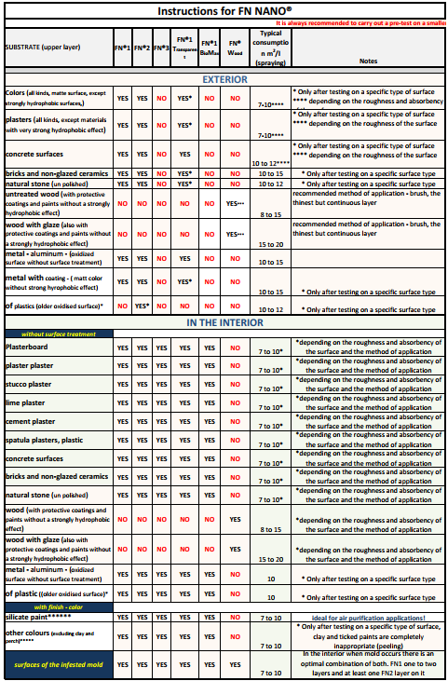

PRINCIPLES ARE THE SAME FOR ALL INTERIOR APPLICATIONS

  - Before first pouring, the FN NANO® should be thoroughly mixed: i.e., SHAKE the bottle, for a minimum of 45 seconds to ensure intense mixing. Before each next pour, we need to shake again the bottle about 10 seconds.
  - When applied with a roller or brush in the tray, we only pour small quantities that we are able to completely use within about 30 minutes.
  - Otherwise, each surface is soaked both a washboard and a brush. The application of FN NANO® should be done in thin layers.
  - For spraying application, we recommend professional or semi-professional spray guns of type HVLP with nozzles designed for paint work. (High Volume Low Pressure https://paintsprayermag.com/types-of-paint-sprayers/)
  - It is advisable to cover the furniture in the room with covering sheets. After you get some practice, you will understand how to properly soak the roller, squeeze out excess, and then apply FN NANO®, you can apply technology with minimal furniture covering. If some of the product drips on to furniture, you need to wash this place immediately with water.
WORKFLOW OF APPLICATION OF FN NANO® COATINGS FOR INTERIOR
We perform the application in the interior with a roller or sprayer - we recommend professional or semi-professional spray guns of the type of HVLP with nozzles designed for paint work. When applying a roller mainly on gypsum board, it is necessary to obtain the proper skill so that we do not soak the underlying material to avoid smears.
When using the FN® 1 BioMAX nano coating, the coating must be “activated” after 24 hours with a fine spray of water. You can spray, for example, with a hand-held sprayer and is carried out with plain or distilled water. This achieves full functionality
Video instructions on how to properly apply FN® nano coatings in the interior:
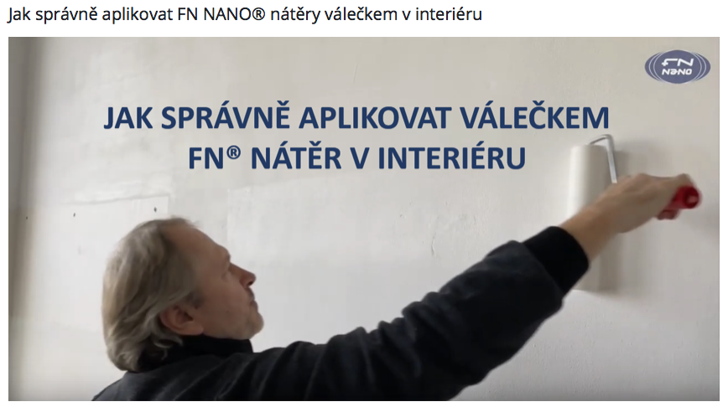
Link to video here: https://www.youtube.com/watch?time_continue=23&v=ikOVHISJ3bg&feature=emb_logo
DESCRIPTION OF THE WORKFLOW IN THE INTERIOR
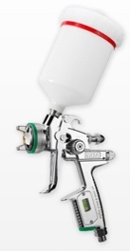
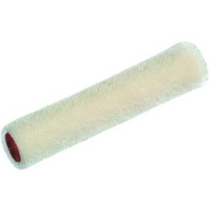
Drywall - older painting:

Aids:

- Always choose a roller with a short hair.
- A paint roller tray.

WORKFLOW:

- If you decide to apply it to existing paint, we recommend that you do a test application
- The test is performed so that in the morning in the room you make one coat of approximately 30x30 cm and wait until the next day
- If the test site remains white and there has been no flaking, cracking and peeling, or no appearance of yellow or other colored spots, we know that the existing color is suitable (in another case we must follow the instructions for the new painting).
Application:
- Carry out the application with a squeezed roller and evenly wet the surface.
- Your should always pour only the amount of material that you need for a short period of time, after shaking.
- We use only small amounts a time so that the tio2 contained withing is not allowed to settle to the bottom of the roller tray, or clog the sprayer.
- When the roller is soaked for the first time, let the FN® nano material be thoroughly absorbed.
- Thereafter, squeeze the roller so that the excess nano material gets out of the roller.
- A thoroughly squeezed roller does not drip during application and the applied layer is continuous and super-thin At the first application, we mostly find out if we have a lot or little material on the roller, and we will regulate further dipping of the roller accordingly.
- We apply to an area of about 70 cm x 70 cm when applied with a small roller. When using a large roller, we enlarge the painted surface —shown in the video example
- We make strokes first in one direction, and then crosswise. The area must be lightly but evenly moistened.
- Working with a suitable second roller goes very quickly and we push the roller only so that the surface just evenly applied. Proceed from the bottom upwards.
- Do not allow that the coating to drip or run down the walls.
- If some place is more wet (there will be a larger layer of nano material on it), we can re-absorb in the almost dry roller and create a uniform surface by stretching the excess nano material to the sides.

- Gradually after sufficient drying between layers, we will create 3 layers. Each of the layers must be as thin and coolest as possible (layer = about 5-30 microns).
- Between individual layers we always wait for the previous layer to dry. You can sense wetness with the back of your hand if you do not have the possibility to use a hygrometer: simply touch the back of your hand to the wall (It should dry in approx. 30 - 60 min. At room temperature)
- After applying all 3 coats, allow the layers to mature for at least 24 hours.
- Common consumption is 8 to 10 m2/1 liter (depends on the absorbency of the surface and the technique used in application).
- In order to ensure the functionality of the created photoactive layer, it is necessary that the surfaces treated with the functional coating FN® be exposed to daylight or illuminated by an artificial ultraviolet (UVA) light source.
- UVA light source is needed in all areas where we want to degrade odors or have the need to clean the air for several hours a day (e.g., with allergens, pets, pollution space of VOC substances, etc.).

- Detailed information to see in a separate section: How to adequately ‘light’ the surface of FN NANO®.

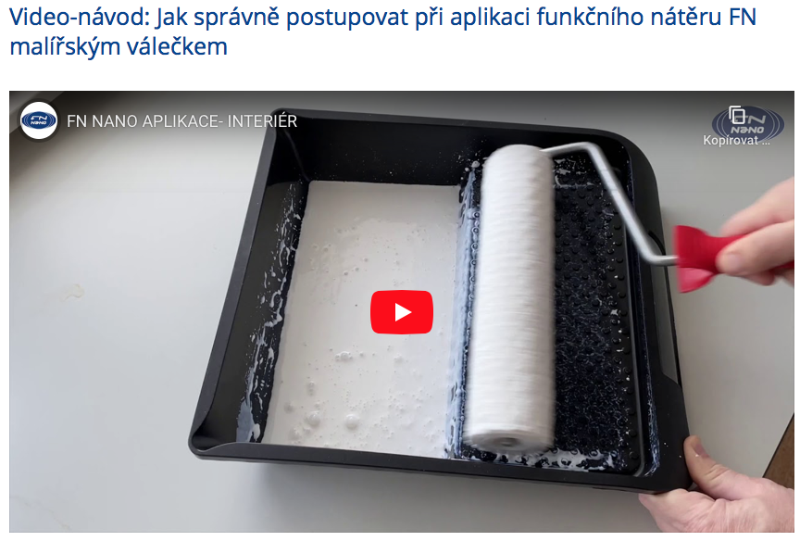
Here you can view the video: https://youtu.be/ikOVHISJ3bg

Plasterboard - new painting:

Aids:

- Always choose a roller with a short hair.
- A paint roller tray.

WORKFLOW:

- It is ideal to apply liquid penetration product to the surface before the new painting to prevent the release of any
substances in the painting.
- It is recommended to use silicate interior paint for painting because of the low VOC content
- We need to leave the underlying paint for at least 24 hours to dry. The primer coatings must dry for a minimum of 24 hours! This is very important.
- After the new painting is matured - at least 24 hours - we have a substrate ready for application of FN NANO® technology

Application:
- Carry out the application with a squeezed roller and evenly wet the surface.
- Your should always pour only the amount of material that you need for a short period of time, after shaking.
- We use only small amounts a time so that the tio2 contained withing is not allowed to settle to the bottom of the roller tray, or clog the sprayer.
- When the roller is soaked for the first time, let the FN® nano material be thoroughly absorbed.
- Subsequently we squeeze the roller thoroughly, really very thoroughly so that the excess nanomaterial gets out of the roller.
- A thoroughly squeezed roller does not drip during application and the applied layer is continuous and super-thin At the first application, we mostly find out if we have a lot or little material on the roller, and we will regulate further dipping of the roller accordingly.
- We apply to an area of about 70 cm x 70 cm when applied with a small roller. When using a large roller, we enlarge the painted surface —shown in the video example
- We make strokes first in one direction, and then crosswise. The area must be lightly but evenly moistened.
- Working with a suitable second roller goes very quickly and we push the roller only so that the surface just evenly applied. Proceed from the bottom upwards.
- Do not allow that the coating to drip or run down the walls.
- If some place is more humidified (there will be a larger layer of nano material on it), we can suction this layer of so-called almost dry roller and create a uniform surface by stretching the excess nano material to the sides.

- Gradually after sufficient drying between layers, we will create 3 layers. Each of the layers must be as thin and coolest as possible (layer = approx. 5-30 microns)
- Between individual layers we always wait for the previous layer to dry. You can sense wetness with the back of your hand if you do not have the possibility to use a hygrometer: simply touch the back of your hand to the wall (It should dry in approx. 30 - 60 min. At room temperature)
- After applying all 3 coats, allow the layers to mature for at least 24 hours.
- Common consumption is 8 to 10 m2/1l (depends on the absorbency of the surface).
- In order to ensure the functionality of the created photoactive layer, it is necessary that the surfaces treated with the functional coating FN® be exposed to daylight or illuminated by an artificial ultraviolet (UVA) light source.
- UVA light source is needed in all areas where we want to degrade odors or have the need to clean the air for several hours a day (e.g., with allergens, pets, pollution space of VOC substances, etc.).
- Detailed information to see in a separate section: How to adequately ‘light’ the surface of FN NANO®.

How and when to light the surface of the FN NANO® UVA

In order to ensure the functionality of the created photoactive layer, it is necessary that the surfaces treated with the functional coating FN® be exposed to daylight or illuminated by an artificial ultraviolet (UVA) light source.

The recommended intensity is 20 μW/cm² (0.2W/1m2). For much polluted spaces, it is recommended to increase this intensity approximately 5x. At stated, UVA resources are completely harmless to the health of both humans and animal darlings.
For an idea: in the winter months in cloudy skies, the intensity of UV radiation in daylight is 10x higher than the recommended indoors saturation values of our coatings.
The optimal wavelength for photoactivation is 365 nm.

Outside (in the exterior), throughout the year (including the winter months) in daylight (even in the shade), contains such an amount of UV radiation that ensures full photocatalytic cleaning performance of the paint layer FN NANO®.
Inside buildings, in interiors, however, the situation is different. There is no daylight in a number of spaces, and where there are windows, very little ultraviolet radiation penetrates through their glass. If we want to ensure good functionality of photocatalytic coating even in the interior where there is not enough UV radiation from daylight, it is necessary that the painted surface is saturated with ultraviolet light with a wavelength of 365 nm (UVA).

While ultraviolet light with shorter wavelengths activates the photocatalytic process too, it can cause harm to health when it is used. Therefore, the use of UV resources referred to as UVB and UVC is recommended only in specialized workplaces such as biolaboratories, hospitals, etc.

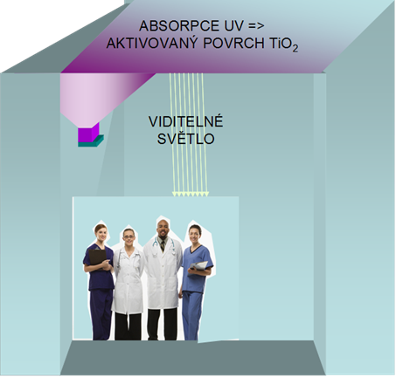
We always install the light source so that the light is directed at the photocatalytic surface created by the FN NANO® coating:

Scheme of possible illumination of the ceiling of the room with a source of UV light:
The minimum power of the source in relation to the enhanced area shall be governed for UVA fluorescent lamps according to rule 1W of the electrical power supply per 1m2 of the saturated area. The minimum intensity of UV-A radiation to ensure the functionality of the photocatalytic area is 0.2W/1m2.

The higher the intensity of UV radiation impacting the photocatalytic surface, the better its surface is able to break down harmful substances in the air and dispose of microorganisms. Follow the instructions of the manufacturers of light sources, and when using UVA lamps with high power, the light was directed to surfaces painted with FN NANO® and did not shine directly into people's eyes.

UVA lights and bulbs can be purchased with normal processes (on-line, mainly). Most commonly used are actinic UVA fluorescent lamps emitting blue-white light or “Disco light” (Black Light) fluorescent lamps emitting UVA radiation in the invisible part of the spectrum. In addition to fluorescent lamps, some types of special lamps and LEDs that produce UVA radiation of the recommended 365 nm wavelength can be used.
For effective lighting, it is important to pay attention to the choice and location of a suitable fixture in which a fluorescent lamp or other UVA light source is placed. When choosing lights, prefer those with aluminum mirror-like reflectors. *Note aluminum foils reflect UV radiation while steel, enamel and other materials absorb it. This san reduce the necessary light output.

Examples of ultraviolet light sources (UVA 365 nm):
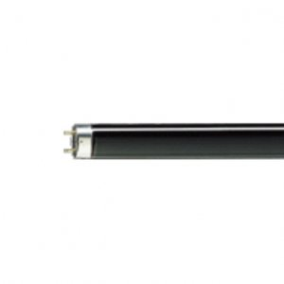
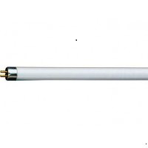
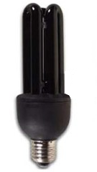
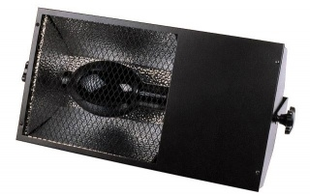
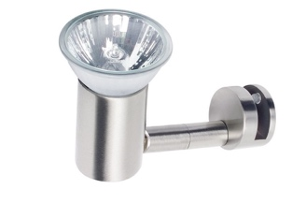

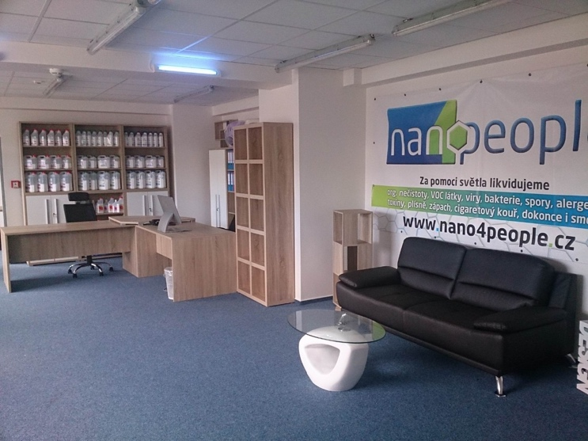
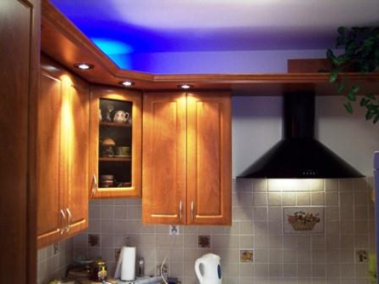
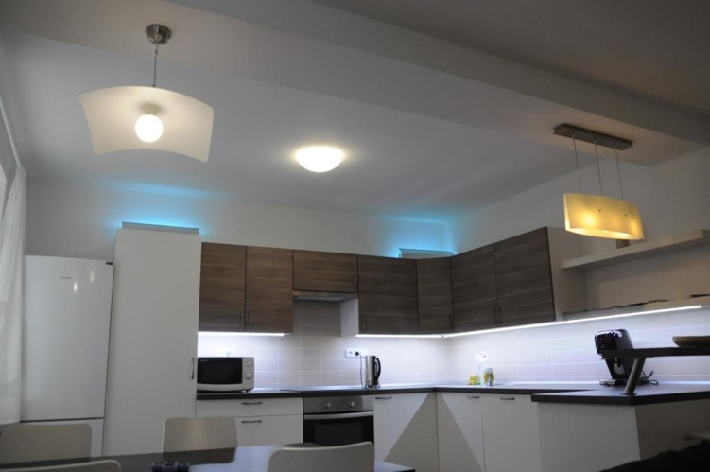
Examples of UVA saturation in interiors:
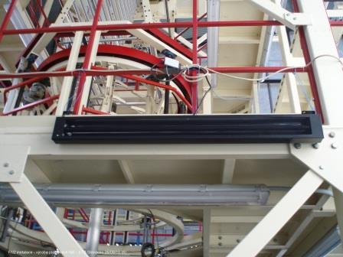

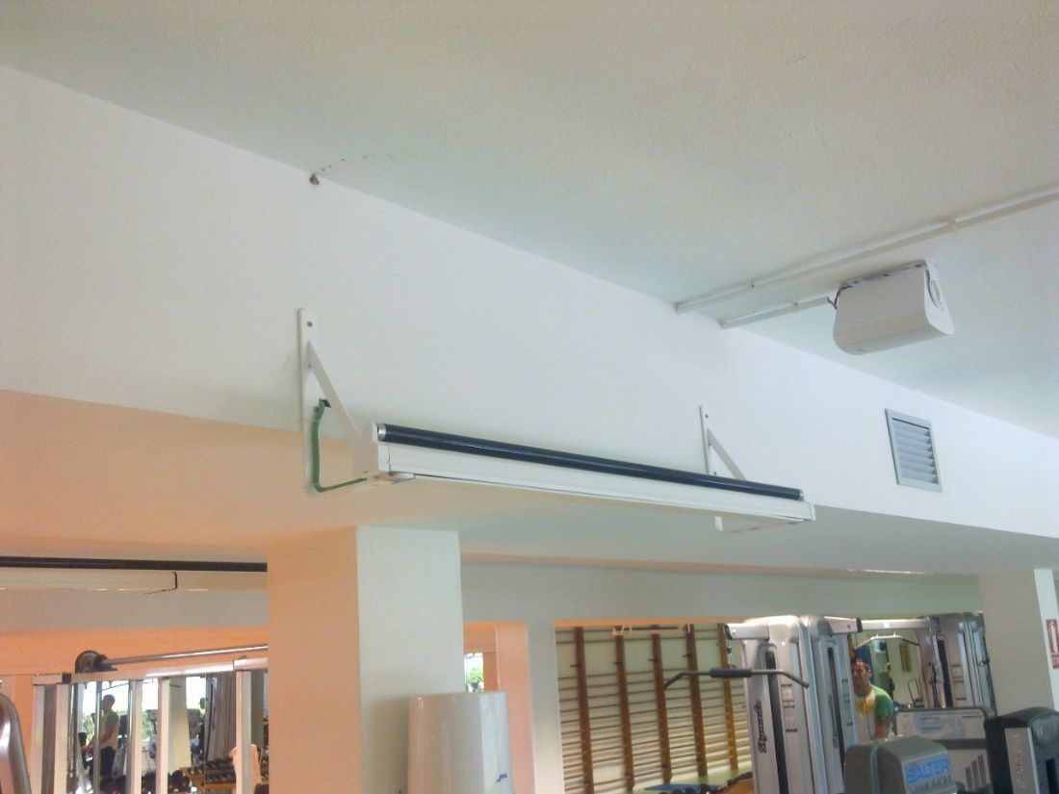

SIMILAR INSTRUCTIONS APLY FOR ALL EXTERIOR APPLICATIONS

  - Before first pouring, the FN NANO® should be thoroughly mixed: i.e., SHAKE the bottle, Approx 45 seconds with intensive mixing. Before each next pour, we need to shake again the bottle about 10 seconds.
  - For outdoor surfaces, we recommend using sprayers.
  - For spraying application, we recommend professional high-pressure spray guns “Airless”.
  - In case of a break in the application or after the end of it, the device should be thoroughly washed with water so that the nano material does not clog the nozzle spray device.
  - When applied with a roller or brush in the tray, we pour only a quantity that we are able to process within about ½ hours — in the exterior designed for small areas around the windows, around the doors, corners and corners.
  - Otherwise, both the roller and brush are soaked for each surface. The application of FN NANO® should be done in thin layers.
  - Ideally, apply in temperature above 10°C outdoors and in dry weather
  - The temperature of the facade should not be over max. 40°C

WORKFLOW OF FN NANO® COATINGS FOR EXTERIOR APPLICATIONS
In particular, we perform the application in the exterior with high-pressure spraying — we recommend professional spray guns of the type “Airless” because of greater productivity and greater coarseness of the facade.

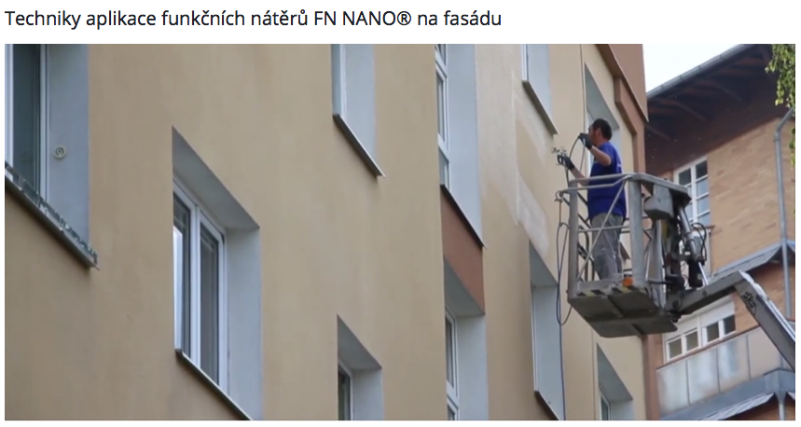
Here you can see the technique of spraying on the facades: https://www.youtube.com/watch?v=Mc5fChv3eQA

DESCRIPTION OF THE EXTERIOR WORKFLOW

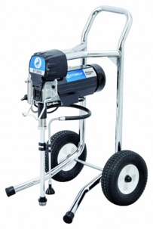
Facade - renovation:

Tools:

- High Pressure Equipment for “Airless” Spraying Technique
- For, corners, surfaces around windows and doors, we can use a brush and roller with a deeper surface (according to the structure of the facade) with a container that has an area to squeeze the roller (don't use a roller grid).
- Paper cardboard for covering windows against errant sprays (aerosol fling from gun)

WORKFLOW:

If we decide to apply to the old and soiled facade, we must first perform the following steps:
1. Gently but thoroughly, wash the facade.
2. Remove all biological infestations (wall mold, lichen, etc) — by using a solution for bacterial treatment.
3. Lightly wash away any crystallized salt on the surface.
4. If necessary, carry out masonry work to repair of the facade.
5. Use surface penetration solution to solidify the surface of the facade from penetrating water and microorganisms from the outside.
6. Overlay with at least one layer of facade primer paint for the coloring of the surface (it is carried out according to the condition of the facade after the overall treatment), or with 2 layers of facade silicate or acrylic paint.
7. After thoroughly drying and maturing (min. 24 hours, but preferably more) of the last primer or color layer, we can start applying nano coating FN NANO®. This technological step must not be shorted in any way.

Application:
- It is best to use the a sprayer on large continuous areas.
- Spray continuously, avoid overlapping and covering the same areas. This could result in visible errors and patchy color.
When buildup happens, immediately correct it with brush or roller to evenly spread the material. Thus, we combine this technique of spraying with a roller, for the reason to dry the excess nano material and evenly “roll” into the surface of the facade.
- To cover areas near windows, doors or small areas, use a roller or brush.
This method is to ensure productivity and even application.
- Carry out the application with a squeezed roller and evenly wet the surface.
- Your should always pour only the amount of material that you need for a short period of time, after shaking.
- We use only small amounts a time so that the tio2 contained withing is not allowed to settle to the bottom of the roller tray, or clog the sprayer.
- When the roller is soaked for the first time, let the FN® nano material be thoroughly absorbed.
- The roller needs to be squeezed thoroughly to avoid dripping. For the facade, unlike the interior, the soaking of the roller is different, and it depends on the coarseness of the facade.
- A thoroughly squeezed roller does not drip during application and the applied layer is continuous and super-thin At the first application, we mostly find out if we have a lot or little material on the roller, and we will regulate further dipping of the roller accordingly.
- Rolling directions are best if done from bottom up and then perpendicular or crosswise. Thus FN NANO® can be applied in all directions. The area must be lightly but evenly moistened. When applying from the bottom up, we make a ripple or wave that is more moist and can carry the FN NANO® into any depressions. This is very important especially for facades and other rough surfaces. Once the material is on the surface, it is possible to stretch the excess material so that a thin layer is distributed evenly. It is desirable to get the roller to a state of “semi-dryness”, and thus the excess material on the surface can be “sponged” back into the roller.
- Do not allow that the coating to drip or run down the walls.

- Gradually after sufficient drying between layers, we will create 3 layers. Each of the layers must be as thin and coolest as possible (layer = about 5-30 microns).
- Between individual layers we always wait for the previous layer to dry. You can sense wetness with the back of your hand if you do not have the possibility to use a hygrometer: simply touch the back of your hand to the wall (It should dry in approx. 30 - 60 min. At room temperature)
- After applying all 3 coating layers of FN NANO®, we let the paint mature at least 24 hours.
- Consumption is normally 6 to 8 m²/liter (depending on the structure and absorbance of the facade surface)
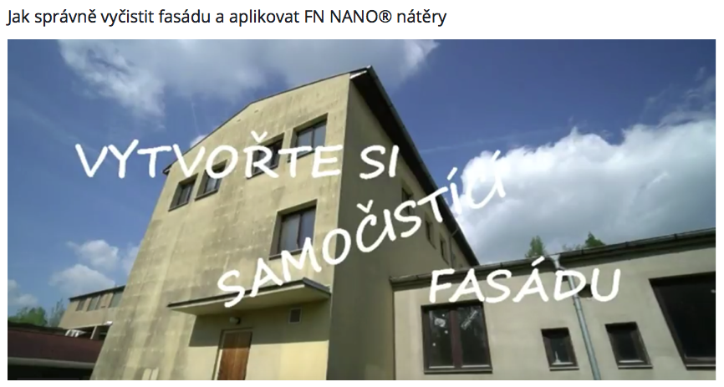
Video on reating a self-cleaning facade: https://www.youtube.com/watch?v=u-kzPHwv4DU

New facade:

Tools:

- High Pressure Equipment for “Airless” Spraying Technique
- For, corners, surfaces around windows and doors, we can use a brush and roller with a deeper surface (according to the structure of the facade) with a container that has an area to squeeze the roller (don't use a roller grid).
- Hand held, paper cardboard for covering windows against errant sprays (aerosol fling with pistols)

WORKFLOW:

After thoroughly drying and maturing (min. 24 hours, but preferably more) the last color layer or stained facade, we can start applying Nano coating FN NANO®. This technological step must not be shorted in any way.

Application:
- It is best to use the a sprayer on large continuous areas.
- Spray continuously, avoid overlapping and covering the same areas. This could result in visible errors and patchy color.
When buildup happens, immediately correct it with brush or roller to evenly spread the material. Thus, we combine this technique of spraying with a roller, for the reason to dry the excess nano material and evenly roll into the surface of the facade.
- To cover areas near windows, doors or small areas, use a roller or brush.
This method is to ensure productivity and even application.
- Carry out the application with a squeezed roller and evenly wet the surface.
- Your should always pour only the amount of material that you need for a short period of time, after shaking.
- We use only small amounts a time so that the tio2 contained withing is not allowed to settle to the bottom of the roller tray, or clog the sprayer.
- When the roller is soaked for the first time, let the FN® nano material be thoroughly absorbed.
- The roller needs to be squeezed thoroughly to avoid dripping. For the facade, unlike the interior, the soaking of the roller is different, and it depends on the coarseness of the facade.
- A thoroughly squeezed roller does not drip during application and the applied layer is continuous and super-thin At the first application, we mostly find out if we have a lot or little material on the roller, and we will regulate further dipping of the roller accordingly.
- Rolling directions are best if done from bottom up and then perpendicular or crosswise. Thus FN NANO® can be applied in all directions. The area must be lightly but evenly moistened. When applying from the bottom up, we make a ripple or wave that is more moist and can carry the FN NANO® into any depressions. This is very important especially for facades and other rough surfaces. Once the material is on the surface, it is possible to stretch the excess material so that a thin layer is distributed evenly. It is desirable to get the roller to a state of “semi-dryness”, and thus the excess material on the surface can be “sponged” back into the roller.
- Do not allow that the coating to drip or run down the walls.

- Gradually after sufficient drying between layers, we will create 3 layers. Each of the layers must be as thin and coolest as possible (layer = about 5-30 microns).
- Between individual layers we always wait for the previous layer to dry. You can sense wetness with the back of your hand if you do not have the possibility to use a hygrometer: simply touch the back of your hand to the wall (It should dry in approx. 30 - 60 min. At room temperature)
- After applying all 3 coating layers of FN NANO®, we let the paint mature at least 24 hours.
- Normal consumption is 6 to 8 m²/liter (depending on the structure and absorbance of the facade surface).

CONCULSION AND IMPORTANT REMINDERS

- NEVER dilute FN NANO® coatings and NEVER mix with other substances like paints or colors!

- Tools are cleaned immediately with water after the end of work.

- FN NANO® comes in plastic containers of 1 Liter or 5 Liters.

- They can be stored for a maximum of 3 years from date of manufacture at 10-25 ° C, in unopened original packaging.
- Do not allow to freeze!
- For nano coating FN® 1 Transparent and FN® Wood, storage is a maximum of 4 months from the date of manufacture at 10-25°C in an unopened original package.

- Before use, mix thoroughly by shaking in the original container. For at least 2 minutes. For colored versions of FN NANO®, it is recommended to mix with a stick mixer after thorough shaking in the original container if it has been sitting in storage for more than 2 months from the date of manufacture to ensure perfect pigment distribution in the liquid.

- Do not apply on a hydrophobic (water-repellent) surface.

- All other information and treatment of individual types of nano coatings of FN NANO® technology can always be found in the relevant technical sheet.

